**Garden Planner proposal**

Nathalie Desrosiers & Nikolay Nikolov

**Project description**

Yes. Garden planner (software or online) do exist. However, they are based on square foot gardening. What if I only want to plant a tiny row of carrots in front of my pepper plant? The current programs won’t allow me to do it. That’s why we came with the idea of a drag and drop garden planner.

First, the client draws (or select) the size and shape of his garden bed(s). Then, selecting from a top A-Z ribbon that contains vegetables, fruits, herbs and flowers, He drags and drops the plant on his virtual garden. Let’s say a tomato is planted somewhere. A window appears, with many varieties to choose from. Depending on the cultivar, it takes between 24” and 36” diameter space. A tool tip would appear suggesting what plants to put next to it: "Asparagus, Basil, Bee Balm, Bush Beans, Cabbage family, Carrot, Celery, Chive, Cucumber, Garlic, Head Lettuce, Marigold, Mint, Nasturtium, Onion, Parsley, Pepper." The client decides to put a potato plant instead. A tool tip would appear stating: "Potato and tomato are garden adversaries" (meaning one plant inhibits another’s growth). Still, he has the final word, so he can still put that potato plant next to the tomato, being fully aware of the awaiting deception. Of course, this client will be able to add a row of carrots (or radishes) in front of the tomato plant, since carrots don’t have to be planted in a square foot grid.

Once the plan is completed, the client will be able to print out his project into a big view of his garden beds, then each garden will be on different pages, depending on his garden beds sizes. After all, nobody wants to bring a valuable computer close to a dirty garden!

Please note that we will take care of the rotation by using 5 different colors of “airbrush”. We will take care of “permanent” crops like asparagus and rhubarb too. Meaning that next year, those special crops will appear “out of the blue” on the new plan if the client prefers so.

**Technologies used:**

* Drag & drop
* Drawing on canvas
* GridSplitter
* .pdf generation
* Printing
* Ribbon (instead of menu)
* StackPanel
* TabControl
* TreeView

**Special features:**

* Ability to control how plants are disposed on the plan
* Facility of knowing companion/adversary plants
* Reliable database for numerous cultivars
* Capacity to generate a pdf
* Capability to print the project
* Reuse of plan the following years
* So easy to use, even a baby can do it!

**Additional libraries:**

* At this time, we don’t know exactly which libraries will be needed.

**Challenging items:**

* Drag & drop
* Drawing on canvas with C#
* GridSplitter
* .pdf generation
* Perenity of certain plants
* Printing
* Ribbon
* Scales
* TabControl
* Tool tips
* TreeView

**Mockups:**

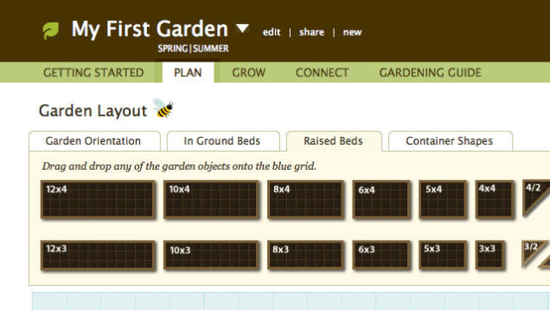

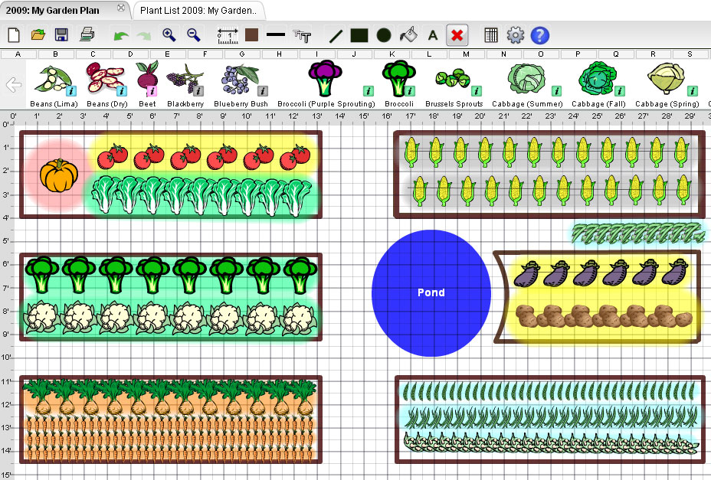

**Database:**

